Operation Manual: NSWC - T310 Submersible Vehicle Kit

Yili Liu, Riley Lessard, Parker Nuzum, Scott Garner, Kenny Le, Justin Llerena
FAMU-FSU College of Engineering
EML4552C/EEL4914C: Senior Design II
Dr. Shayne McConomy, Dr. Oscar Chuy
April 18, 2025

Project Overview
This project is a submersible vehicle kit made in partnership with the Naval Surface Warfare Center of Panama City Division, the goal of this project is to provide an affordable kit that educational programs 6-12th grade can use to educate students on STEM topics such as buoyancy, electrical wiring, control, etc. The final assembled submersible will be able to operate at depths of 20 feet, be controlled through a video game controller, and provide live video feedback to an onland control station. All this will be available at a cost of under 500 dollars.

Component/Module Description
Submersible Outer Body

Rear body piece
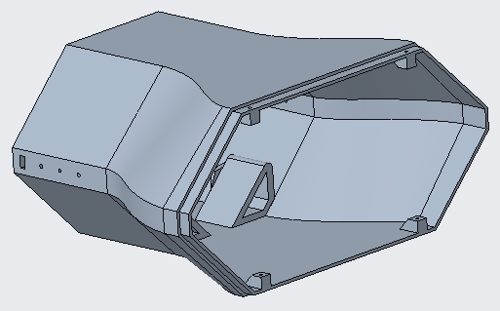
  - Printed using PLA on a 3D Printer (Preferably Prusa XL).
  - Mounts two APISQUEEN U01 underwater thrusters (lateral) using screws.
  - 4 screw points for front body pieces using M3x10mm self tapping screws.
  - 2 screw points for endcap using M3x10mm self tapping screws.

Front lower body piece
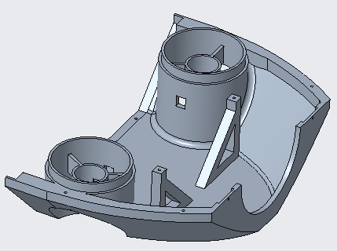
  - Printed using PLA on a 3D Printer (Preferably Prusa XL).
  - Mounts two APISQUEEN U01 underwater thrusters (vertical) using screws.
  - Clamping points for waterproof hull, using 2 M3x14mm self tapping screws.
  - 8 total screw holes for assembling the rear and front upper body piece, using M3x10mm self tapping screws.

Front upper body piece
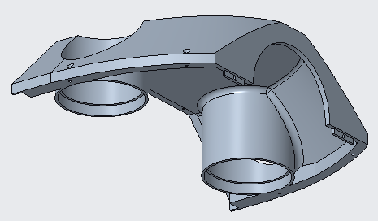
  - Printed using PLA on a 3D Printer (Preferably Prusa XL).
  - 8 total screw holes for assembling the rear and front upper body piece, using M3x10mm self tapping screws.

Endcap
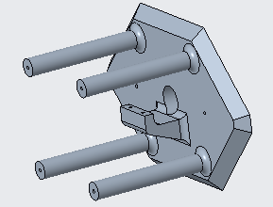
  - Printed using PLA on a 3D Printer (Preferably Prusa XL).
  - Fits up to 40 cm total length of buoyancy foam (pool noodles).
  - Clamping points for tether, using 2 M3x10mm self tapping screws.
  - 2 M3x10mm screws for mounting to the rear body piece.

Clamp
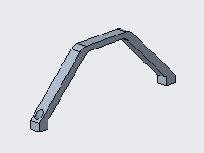
  - Printed using PLA on a 3D Printer (Preferably Prusa XL).
  - Clamps onto the front lower body piece using 2 M3x14mm screws to hold the waterproof hull in place.

Power and Data:
- Schematic
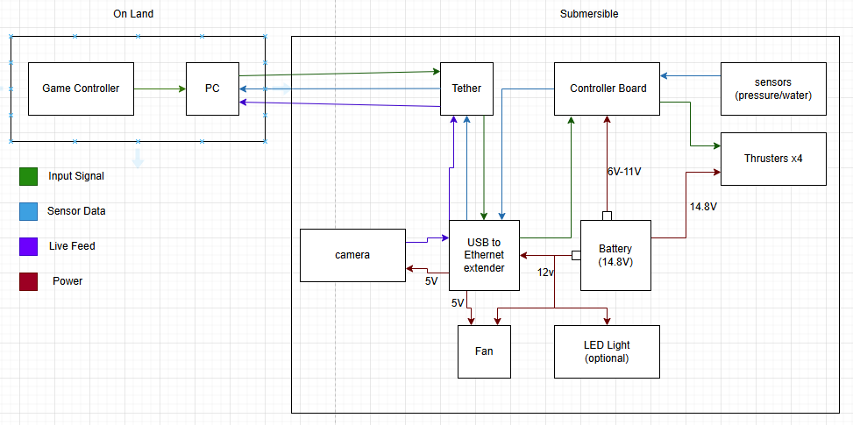
  - 2 Main Blocks
    - On Land(Game Controller,Pc,Tether)
    - Submersible(Tether,Usb to Ethernet,Camera,Controller Board,thrusters,sensors,LED Light,Fan)
    - Small Squares (Buck converter)
- Power System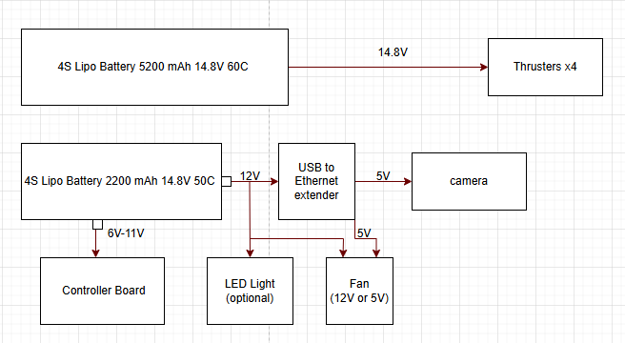
  - 2 Batteries
    - 14.8V
    - 5200mAh,60C (4 Thrusters,Voltameter)
    - 2200mAH,50C (Controller Board, USB to Ethernet extender, LED Light, Fan 12V or 5V)

- Breakdown (60C)
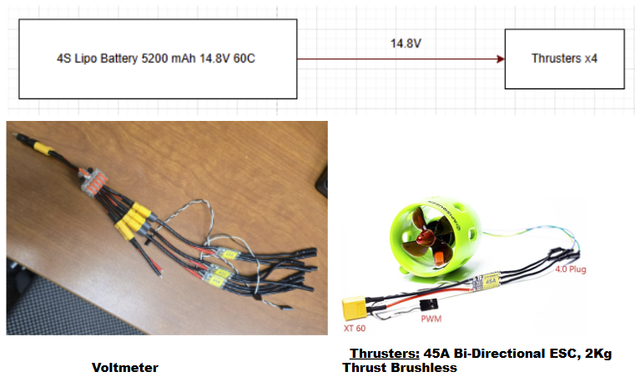
- 1 to 5 power connection
  - 4 Thrusters
  - Voltameter
- Runtime
  - 5.2 Ah
  - Run time under normal operation (1.05 h)

- Breakdown (50C)
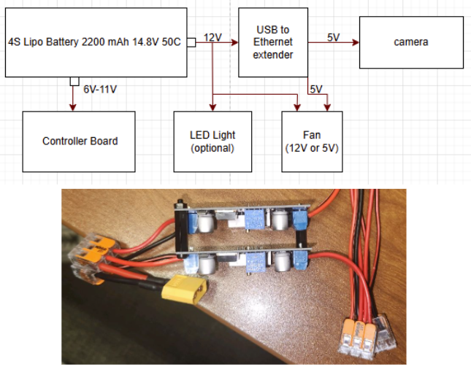
- 1 to 2 power connection
- 2 buck converters (9V,12V)
- 1 to 3 power connection (12V) (USB to Ethernet Extender,LED Light,Fan)
- Run Time
  - 2.2 Ah Battery
  - Run Time (1.15 h)

- Electronics tray
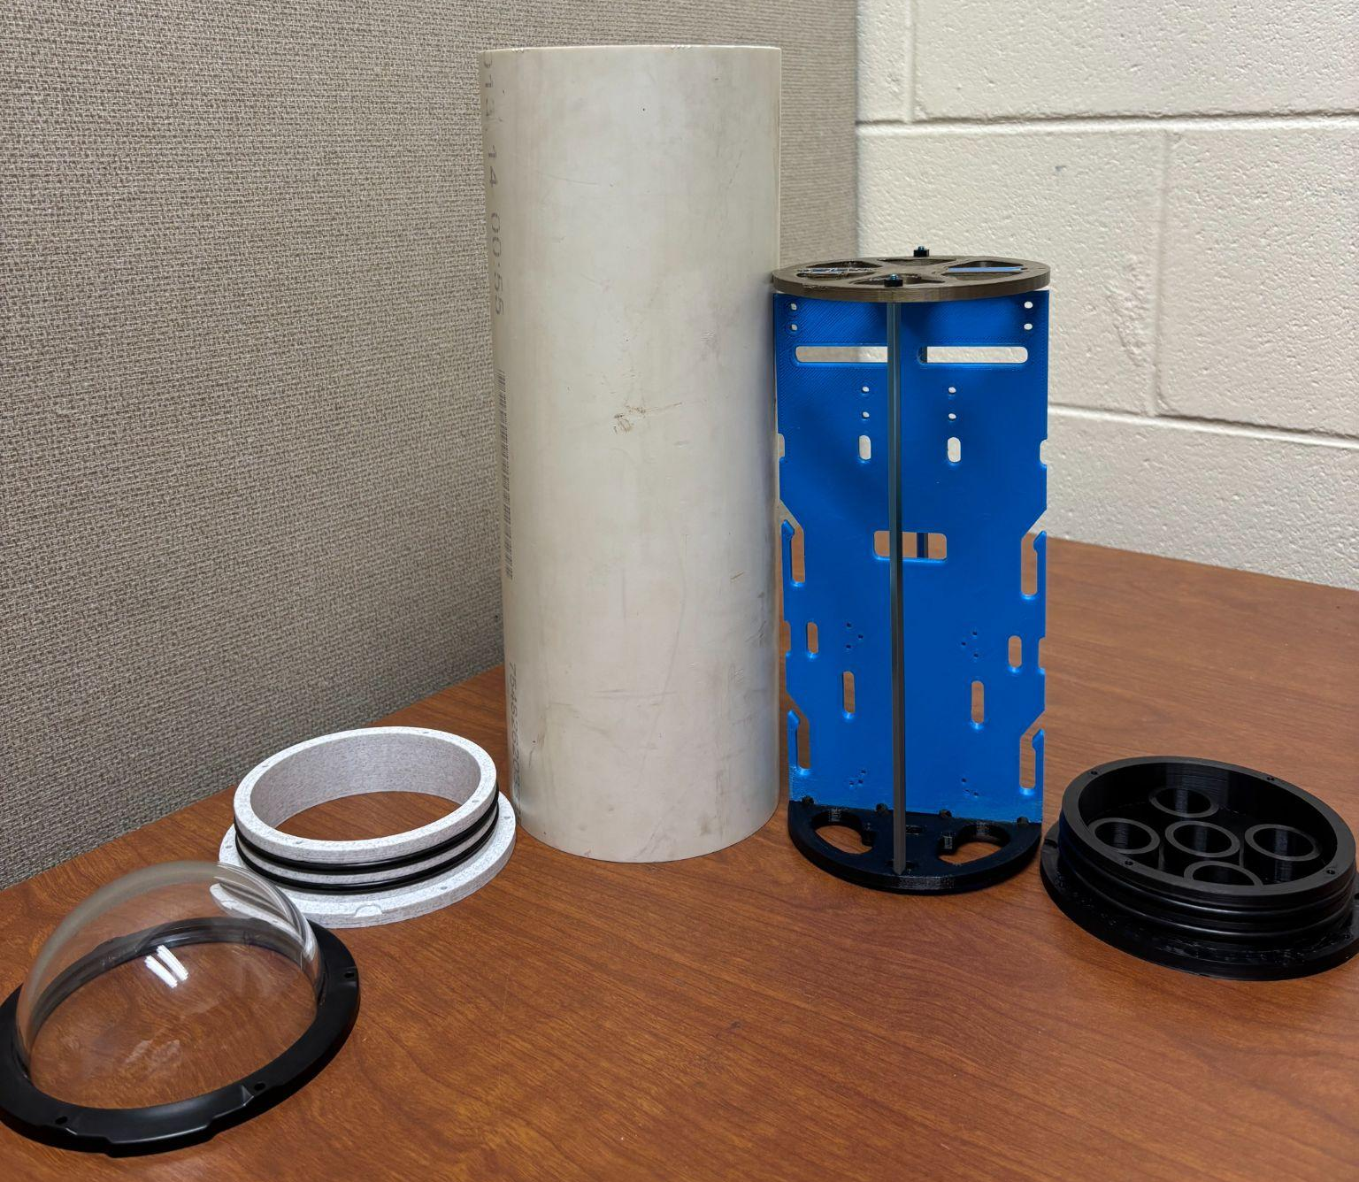
- Houses all non waterproof electronics
  - USB to ethernet extender, batteries, controller board, connections, Fan,Voltameter,Camera
  - Top(Main electronics, connections)
  - Bottom(Batteries,Buck Converters,connections)

Software Architecture:
The system comprises three key Python scripts, each serving a specific role in the software architecture. These are main.py, acce_test.py, and dashboard.py. The applications that were used are Thonny and Visual Studio Code. Pseudocode will be provided in the appendix section.

Applications:
download python
https://www.python.org/downloads/
download vs code
https://code.visualstudio.com/
install python extension
open the folder as a project
python -m pip install pygame
python -m pip install serial
pip install pyserial
pip install opencv-python opencv-python-headless
py -m pip install pillow

Code:
- The main.py script runs directly on the XRP Beta board and controls the ROV’s hardware. It initializes all the motors, sensors (IMU, pressure, and internal temperature), and sets up a serial communication loop. When it receives joystick commands from the laptop, it updates the PWM values for the thrusters. If depth-hold is enabled, it uses a PID controller to automatically adjust the vertical thrusters to maintain the set depth. It continuously reads sensor data and sends back telemetry information over serial to the laptop, including motor speeds, orientation, depth, and temperatures.
- The acce_test.py script is the bridge between the Xbox controller and the XRP board. It reads real-time joystick inputs, translates them into motor commands, and sends those as PWM values over a serial connection to the XRP. It also listens for telemetry data returned from the XRP and updates a shared telemetry dictionary. It launches the dashboard GUI in a background thread. Additionally, the A, Y, and B buttons are mapped to toggle depth hold, set the target depth, and zero the relative depth, respectively.
- The dashboard.py script is responsible for the real-time graphical interface. It displays all telemetry data (joystick inputs, IMU readings, temperatures, depth, and motor values) in a simple tkinter GUI. It also shows a live camera feed from a connected webcam and allows the user to start/stop video recording with a single button. The interface updates regularly using background threads and tkinter’s scheduling system, ensuring smooth visuals and consistent feedback for the user.
Note: All custom sensor drivers (imu.py, lps33.py, and PicoSensor.py) must be uploaded to the XRP Beta board and should be left unchanged unless hardware is modified. These files are essential for correct sensor communication and telemetry output. The driver files are available through WPI library and Raspberry Pi Pico library online.

Integration

Submersible Outer Body Assembly
*This process begins once wiring and electronics are fully assembled and are fit into the waterproof hull.
*Thrusters should be mounted onto rear and front lower body pieces already and wires fed through their respective holes before beginning this process.
- Lay rear and front lower body pieces on a flat surface and seat the lips onto each other until the screw holes are aligned. (Pictured below)
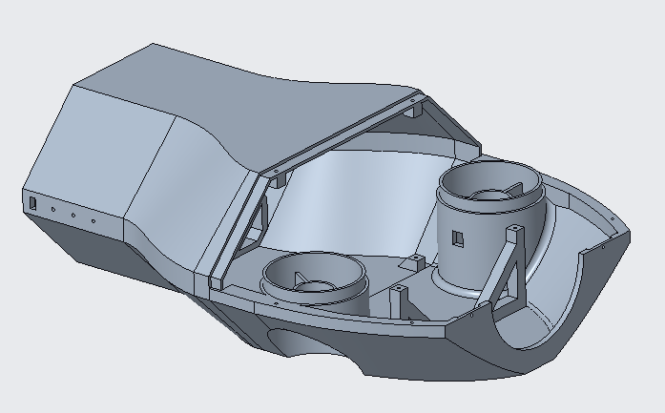
- Slide the waterproof hull (PVC pipe) rear first into the rear body piece until fully seated between the clamps and on the integrated stops. Then attach the clamp to the front lower body piece and over the waterproof hull. Tighten the 2 M3x14mm screws until the waterproof hull is secured. (Pictured below).
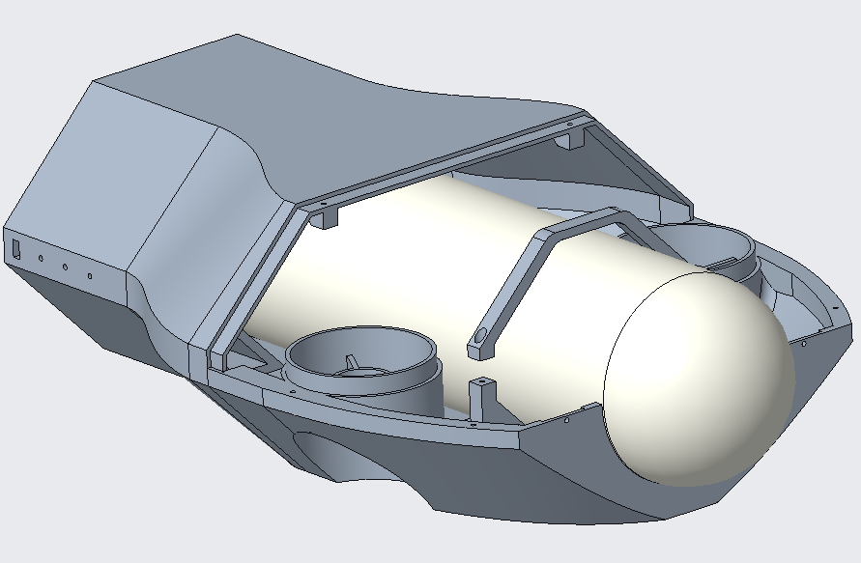
- Place the front upper body piece onto the front lower body piece, making sure to line up the vertical motor housings and press down firmly. The front latches should snap into place. Begin screwing all body pieces together using M3x10mm screws, starting with the mating joint between the rear and front upper body piece, then the front 2 holes next to the dome. Then finish with the 4 screws along the sides and finally flip the submersible over and screw in the corresponding mating surface between the rear and front lower body piece. (Pictured below)
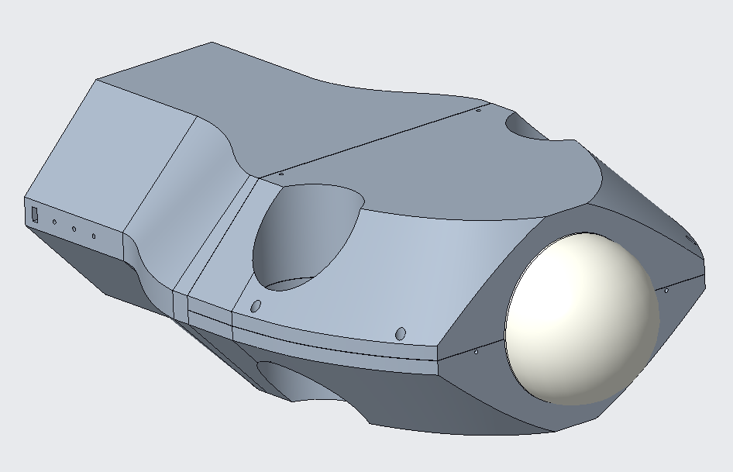
- Once all electrical connections are made, run the ethernet tether through the hole in the end cap and seat the end cap into its respective circular cutout on the rear body piece, making sure to line the 2 M3 holes up. Then screw into place using M3x10mm screws. (Pictured below)
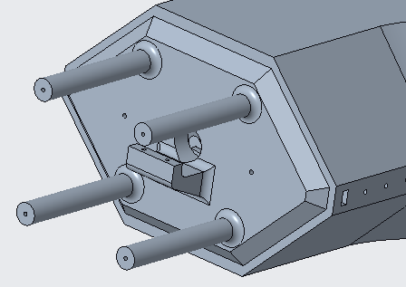

- Finally, clamp the tether using the tether clamp piece onto the end cap using two M3x10mm screws, tightening until the tether cannot be pulled through. (Pictured below)
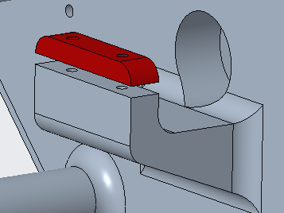

Operation Instructions

Startup
- Ensure the 4S 14.8V LiPo battery is fully charged before use.
- Connect the battery to the power distribution block inside the hull.
- Connect the tether to both the submersible vehicle and the topside control station.
- Power on the XRP controller board and confirm the onboard LED lights up.
- Connect the Xbox controller to the PC.
- Launch the control software (/scripts/thruster_control.py and /scripts/camera_feed.py) on the PC.
- Verify that the live camera feed is active.

Basic Controls
- Left joystick: Forward and backward motion
- Right joystick: Turning and vertical movement (ascend/descend)

Operation Notes
- Operate only in clean, freshwater environments such as pools.
- Do not exceed a depth of 20 feet.
- Avoid contact with pool walls and floors at high speeds.
- Always monitor the camera feed for surroundings and orientation.
- If using an external power supply instead of the battery, ensure it matches the voltage and current specifications.

Shutdown Procedure
- Safely surface the vehicle.
- Exit the control software on the PC.
- Power off the XRP controller.
- Disconnect the battery and tether.
- Wipe down the vehicle and dry all components before storage.
- Store the battery in a fire-safe bag and recharge if needed.

Safety Tips
- Never operate the submersible unattended.
- Keep electronics away from water during setup.
- Do not touch exposed wiring while the system is powered.

Troubleshooting

Issue: No power to vehicle
Possible Cause: Battery not connected or dead
Solution: Ensure the 4S battery is fully charged and securely connected. Check battery voltage.

Issue: Thrusters do not respond
Possible Cause: ESC or motor connection is loose or damaged
Solution: Inspect motor wires and ESC connectors. Ensure PWM cables are connected to the correct pins on the XRP board.

Issue: Vehicle only turns in one direction
Possible Cause: One or more thrusters not functioning
Solution: Test each thruster individually using direct commands. Replace any non-responsive thruster or ESC.

Issue: Camera feed is black or frozen
Possible Cause: Camera not receiving power or loose SPI/USB connection
Solution: Reconnect camera cables. Restart the /scripts/camera_feed.py script.

Issue: Game controller not recognized
Possible Cause: Driver issue or controller not paired
Solution: Unplug and reconnect the controller. Reboot PC. Confirm it’s recognized in control software.

Issue: Vehicle drifts or tilts uncontrollably
Possible Cause: Uneven weight distribution or thrusters mounted off-axis
Solution: Adjust ballast skids or reposition internal components for better center of gravity. Check thruster alignment.

Issue: No communication via tether
Possible Cause: Broken wire or poor connector seal
Solution: Test continuity across tether wires. Check for water damage or exposed connectors. Replace tether if needed.

Issue: Water intrusion in hull
Possible Cause: O-ring damaged, epoxy seal failed
Solution: Inspect and replace O-rings. Reapply waterweld epoxy to affected penetrators. Test hull under shallow pressure.

Issue: XRP board not booting
Possible Cause: Firmware issue or electrical short
Solution: Reflash firmware if unresponsive. Inspect board for signs of corrosion or loose solder joints.

Issue: Battery drains too quickly
Possible Cause: Overuse of thrusters or other components
Solution: Reduce power usage. Avoid constant full-throttle operation. Use external power supply for bench testing.

Appendix A: Pseudocode

main.py:
Initialize PWM pins for motors (mL, mR, m3, m4) at 50 Hz
Initialize I2C-connected IMU sensor
Initialize I2C-connected LPS33 pressure sensor
Initialize onboard internal temperature sensor
Initialize LED pin for activity indicator
Start polling for serial input

Set PID constants (Kp, Ki, Kd)
Set PID state variables (integral, last_error, last_time)
Set initial depth hold settings (depth_hold_enabled = False, target_depth = 0.0)
Set depth_offset = 0.0 for relative depth

Define hold_depth(current_depth):
Compute error between target_depth and current depth
Compute time delta (dt)
Compute PID terms (integral and derivative)
Calculate effort using PID formula
Clamp effort between -1 and 1
Convert effort to PWM pulse width and return it

Start main loop:
Toggle LED to indicate activity

If serial input is available:
Read a line from serial

If command is "ZERO_DEPTH":
Read pressure from LPS33
Set depth_offset = pressure converted to cm
Continue to next iteration

Parse incoming command line: pwm1, pwm2, pwm3, pwm4, depth_hold_flag, target_depth

If depth hold is enabled:
Read pressure from LPS33
Convert to depth_cm
Calculate relative_depth_cm = depth_cm - depth_offset
Compute PWM output for vertical thrusters (m3 and m4) using hold_depth()

Apply all PWM values to motors
Read IMU values (acceleration, gyroscope, pitch, roll, yaw)
Read pressure and temperature from LPS33
Convert pressure to depth_cm
Read internal temperature from onboard ADC

Print telemetry string:
Includes motor values, IMU, depth, pressure, temperatures, depth_hold state, and relative depth

End loop and repeat

Acce_test.py:
Import joystick and serial libraries
Import dashboard thread and shared telemetry dictionary
Initialize serial connection to XRP (set COM port)

Initialize pygame and connect to Xbox controller

Define helper functions:
clamp(value): restrict value to [-1.0, 1.0]
apply_deadzone(value): remove small joystick noise
normalize_axis(raw_value): apply clamp and deadzone
map_effort_to_pwm(effort): convert joystick effort to PWM signal

Start dashboard thread (runs GUI in background)

Initialize IMU data and depth hold tracking variables
Initialize last button press trackers

Start main loop:
Poll controller inputs

Read left and right joystick values for:
- forward (surge)
- yaw (rotate)
- pitch and roll (heave and tilt)

Read button states: A, Y, B

If A is newly pressed:
Toggle depth hold flag
Print status message

If Y is newly pressed:
Set target_depth = current relative depth from telemetry
Print new target message

If B is newly pressed:
Send "ZERO_DEPTH" command to XRP
Print confirmation

If all joystick axes are 0:
Set all PWM signals to neutral (4915)
Else:
Map joystick inputs to motor efforts (surge, yaw, pitch, roll)
Convert to PWM values for m1–m4

Create command string with pwm1–pwm4, depth hold flag, and target depth
Send command to XRP over serial

If serial response is available:
Read and decode line
If line starts with "TELEMETRY:":
Parse data into:
- PWM values
- IMU readings
- Pressure + temperature + depth
- Depth hold state
- Relative depth
Update shared telemetry dictionary

Update telemetry dictionary with joystick and PWM values

Sleep briefly to limit CPU usage
Repeat loop

dashboard.py:
Import tkinter for GUI, threading for updates, and OpenCV for camera
Import PIL for displaying camera frames in tkinter

Initialize shared telemetry dictionary
Initialize video recording state (recording = False, video_writer = None)

Define update_loop(labels):
Loop forever:
Try:
Update each GUI label with current telemetry data:
- Joystick values
- Thruster PWM values
- IMU values (acceleration, gyro, orientation)
- External and internal temperatures
- Depth (absolute and relative)
- Depth hold status and target
Set color based on depth hold state
Except:
Pass (ignore GUI errors)
Sleep briefly (0.1s)

Define update_camera(cam_label, cap, root):
Read one frame from camera
If successful:
Convert frame to RGB
Display in GUI using ImageTk
If recording:
Write frame to video file
Schedule next update with root.after()

Define toggle_record():
If not recording:
Create new video file using timestamp
Start writing frames
Update button text to "Stop Recording"
Else:
Stop and release video writer
Reset button text to "Start Recording"

Define run_dashboard():
Create tkinter window
Create and pack labels for telemetry categories
Create and pack record button
Create and pack camera preview label

Open camera stream (usually `cv2.VideoCapture(2)`)

Start update loop in a background thread
Start update_camera loop using `root.after()`

Start tkinter mainloop()

Appendix B: Driver Files

imu.py:
# LSM6DSO 3D accelerometer and 3D gyroscope seneor micropython drive
# ver: 1.0
# License: MIT
# Author: shaoziyang (shaoziyang@micropython.org.cn)
# v1.0 2019.7

from imu_defs import *
from uctypes import struct, addressof
from machine import I2C, Pin, Timer, disable_irq, enable_irq
import time, math

class IMU():

_DEFAULT_IMU_INSTANCE = None

@classmethod
def get_default_imu(cls):
"""
Get the default XRP IMU instance. This is a singleton, so only one instance of the drivetrain will ever exist.
"""

if cls._DEFAULT_IMU_INSTANCE is None:
cls._DEFAULT_IMU_INSTANCE = cls()
cls._DEFAULT_IMU_INSTANCE.calibrate()
return cls._DEFAULT_IMU_INSTANCE

def __init__(self, scl_pin: int|str = "I2C_SCL_1", sda_pin: int|str = "I2C_SDA_1", addr=LSM_ADDR_PRIMARY):
# I2C values
self.i2c = I2C(id=1, scl=Pin(scl_pin), sda=Pin(sda_pin), freq=400000)
self.addr = addr

# Initialize member variables
self._reset_member_variables()

# Transmit and recieve buffers
self.tb = bytearray(1)
self.rb = bytearray(1)

# Copies of registers. Bytes and structs share the same memory
# addresses, so changing one changes the other
self.reg_ctrl1_xl_byte = bytearray(1)
self.reg_ctrl2_g_byte = bytearray(1)
self.reg_ctrl3_c_byte = bytearray(1)
self.reg_ctrl1_xl_bits = struct(addressof(self.reg_ctrl1_xl_byte), LSM_REG_LAYOUT_CTRL1_XL)
self.reg_ctrl2_g_bits = struct(addressof(self.reg_ctrl2_g_byte), LSM_REG_LAYOUT_CTRL2_G)
self.reg_ctrl3_c_bits = struct(addressof(self.reg_ctrl3_c_byte), LSM_REG_LAYOUT_CTRL3_C)

# Create timer
self.update_timer = Timer(-1)

# Check if the IMU is connected
if not self.is_connected():
# TODO - do somehting intelligent here
pass

# Reset sensor to clear any previous configuration
# reset() also sets the board to the default config
self.reset()

def _default_config(self):
# Enable block data update
self._set_bdu()

# Set default scale for each sensor
self.acc_scale('16g')
self.gyro_scale('2000dps')

# Set default rate for each sensor
self.acc_rate('208Hz')
self.gyro_rate('208Hz')

"""
The following are private helper methods to read and write registers, as well as to convert the read values to the correct unit.
"""

def _reset_member_variables(self):
# Vector of IMU measurements
self.irq_v = [[0, 0, 0], [0, 0, 0]]

# Sensor offsets
self.gyro_offsets = [0,0,0]
self.acc_offsets = [0,0,0]

# Scale factors when ranges are changed
self._acc_scale_factor = 1
self._gyro_scale_factor = 1

# Angle integrators
self.running_pitch = 0
self.running_yaw = 0
self.running_roll = 0

def _int16(self, d):
return d if d < 0x8000 else d - 0x10000

def _setreg(self, reg, dat):
self.tb[0] = dat
self.i2c.writeto_mem(self.addr, reg, self.tb)

def _getreg(self, reg):
self.i2c.readfrom_mem_into(self.addr, reg, self.rb)
return self.rb[0]

def _getregs(self, reg, num_bytes):
rx_buf = bytearray(num_bytes)
self.i2c.readfrom_mem_into(self.addr, reg, rx_buf)
return rx_buf

def _get2reg(self, reg):
return self._getreg(reg) + self._getreg(reg+1) * 256

def _r_w_reg(self, reg, dat, mask):
self._getreg(reg)
self.rb[0] = (self.rb[0] & mask) | dat
self._setreg(reg, self.rb[0])

def _set_bdu(self, bdu = True):
"""
Sets Block Data Update bit
"""
self.reg_ctrl3_c_byte[0] = self._getreg(LSM_REG_CTRL3_C)
self.reg_ctrl3_c_bits.BDU = bdu
self._setreg(LSM_REG_CTRL3_C, self.reg_ctrl3_c_byte[0])

def _set_if_inc(self, if_inc = True):
"""
Sets InterFace INCrement bit
"""
self.reg_ctrl3_c_byte[0] = self._getreg(LSM_REG_CTRL3_C)
self.reg_ctrl3_c_bits.IF_INC = if_inc
self._setreg(LSM_REG_CTRL3_C, self.reg_ctrl3_c_byte[0])

def _raw_to_mg(self, raw):
return self._int16((raw[1] << 8) | raw[0]) * LSM_MG_PER_LSB_2G * self._acc_scale_factor

def _raw_to_mdps(self, raw):
return self._int16((raw[1] << 8) | raw[0]) * LSM_MDPS_PER_LSB_125DPS * self._gyro_scale_factor

"""
Public facing API Methods
"""

def is_connected(self):
"""
Checks whether the IMU is connected

:return: True if WHO_AM_I value is correct, otherwise False
:rtype: bool
"""
who_am_i = self._getreg(LSM_REG_WHO_AM_I)
return who_am_i == LSM_WHO_AM_I_VALUE

def reset(self, wait_for_reset = True, wait_timeout_ms = 100):
"""
Resets the IMU, and restores all registers to their default values

:param wait_for_reset: Whether to wait for reset to complete
:type wait_for_reset: bool
:param wait_timeout_ms: Timeout in milliseconds when waiting for reset
:type wait_timeout_ms: int
:return: False if timeout occurred, otherwise True
:rtype: bool
"""
# Stop timer
self._stop_timer()

# Reset member variables
self._reset_member_variables()

# Set BOOT and SW_RESET bits
self.reg_ctrl3_c_byte[0] = self._getreg(LSM_REG_CTRL3_C)
self.reg_ctrl3_c_bits.BOOT = 1
self.reg_ctrl3_c_bits.SW_RESET = 1
self._setreg(LSM_REG_CTRL3_C, self.reg_ctrl3_c_byte[0])

# Wait for reset to complete, if requested
if wait_for_reset:
# Loop with timeout
t0 = time.ticks_ms()
while time.ticks_ms() < (t0 + wait_timeout_ms):
# Check if register has returned to default value (0x04)
self.reg_ctrl3_c_byte[0] = self._getreg(LSM_REG_CTRL3_C)
if self.reg_ctrl3_c_byte[0] == 0x04:
self._default_config()
self._start_timer()
return True
# Timeout occurred
# Attempt to set default config anyways
self._default_config()
self._start_timer()
return False
else:
self._default_config()
self._start_timer()
return True

def get_acc_x(self):
"""
:return: The current reading for the accelerometer's X-axis, in mg
:rtype: int
"""
# Burst read data registers
raw_bytes = self._getregs(LSM_REG_OUTX_L_A, 2)

# Convert raw data to mg's
return self._raw_to_mg(raw_bytes[0:2]) - self.acc_offsets[0]

def get_acc_y(self):
"""
:return: The current reading for the accelerometer's Y-axis, in mg
:rtype: int
"""
# Burst read data registers
raw_bytes = self._getregs(LSM_REG_OUTY_L_A, 2)

# Convert raw data to mg's
return self._raw_to_mg(raw_bytes[0:2]) - self.acc_offsets[1]

def get_acc_z(self):
"""
:return: The current reading for the accelerometer's Z-axis, in mg
:rtype: int
"""
# Burst read data registers
raw_bytes = self._getregs(LSM_REG_OUTZ_L_A, 2)

# Convert raw data to mg's
return self._raw_to_mg(raw_bytes[0:2]) - self.acc_offsets[2]

def get_acc_rates(self):
"""
:return: the list of readings from the Accelerometer, in mg. The order of the values is x, y, z.
:rtype: list<int>
"""
# Burst read data registers
raw_bytes = self._getregs(LSM_REG_OUTX_L_A, 6)

# Convert raw data to mg's
self.irq_v[0][0] = self._raw_to_mg(raw_bytes[0:2]) - self.acc_offsets[0]
self.irq_v[0][1] = self._raw_to_mg(raw_bytes[2:4]) - self.acc_offsets[1]
self.irq_v[0][2] = self._raw_to_mg(raw_bytes[4:6]) - self.acc_offsets[2]

return self.irq_v[0]

def get_gyro_x_rate(self):
"""
Individual axis read for the Gyroscope's X-axis, in mdps
"""
# Burst read data registers
raw_bytes = self._getregs(LSM_REG_OUTX_L_G, 2)

# Convert raw data to mdps
return self._raw_to_mdps(raw_bytes[0:2]) - self.gyro_offsets[0]

def get_gyro_y_rate(self):
"""
Individual axis read for the Gyroscope's Y-axis, in mdps
"""
# Burst read data registers
raw_bytes = self._getregs(LSM_REG_OUTY_L_G, 2)

# Convert raw data to mdps
return self._raw_to_mdps(raw_bytes[0:2]) - self.gyro_offsets[1]

def get_gyro_z_rate(self):
"""
Individual axis read for the Gyroscope's Z-axis, in mdps
"""
# Burst read data registers
raw_bytes = self._getregs(LSM_REG_OUTZ_L_G, 2)

# Convert raw data to mdps
return self._raw_to_mdps(raw_bytes[0:2]) - self.gyro_offsets[2]

def get_gyro_rates(self):
"""
Retrieves the array of readings from the Gyroscope, in mdps
The order of the values is x, y, z.
"""
# Burst read data registers
raw_bytes = self._getregs(LSM_REG_OUTX_L_G, 6)

# Convert raw data to mdps
self.irq_v[1][0] = self._raw_to_mdps(raw_bytes[0:2]) - self.gyro_offsets[0]
self.irq_v[1][1] = self._raw_to_mdps(raw_bytes[2:4]) - self.gyro_offsets[1]
self.irq_v[1][2] = self._raw_to_mdps(raw_bytes[4:6]) - self.gyro_offsets[2]

return self.irq_v[1]

def get_acc_gyro_rates(self):
"""
Get the accelerometer and gyroscope values in mg and mdps in the form of a 2D array.
The first row is the acceleration values, the second row is the gyro values.
The order of the values is x, y, z.
"""
# Burst read data registers
raw_bytes = self._getregs(LSM_REG_OUTX_L_G, 12)

# Convert raw data to mg's and mdps
self.irq_v[0][0] = self._raw_to_mg(raw_bytes[6:8]) - self.acc_offsets[0]
self.irq_v[0][1] = self._raw_to_mg(raw_bytes[8:10]) - self.acc_offsets[1]
self.irq_v[0][2] = self._raw_to_mg(raw_bytes[10:12]) - self.acc_offsets[2]
self.irq_v[1][0] = self._raw_to_mdps(raw_bytes[0:2]) - self.gyro_offsets[0]
self.irq_v[1][1] = self._raw_to_mdps(raw_bytes[2:4]) - self.gyro_offsets[1]
self.irq_v[1][2] = self._raw_to_mdps(raw_bytes[4:6]) - self.gyro_offsets[2]

return self.irq_v

def get_pitch(self):
"""
Get the pitch of the IMU in degrees. Unbounded in range

:return: The pitch of the IMU in degrees
:rtype: float
"""
return self.running_pitch

def get_yaw(self):
"""
Get the yaw (heading) of the IMU in degrees. Unbounded in range

:return: The yaw (heading) of the IMU in degrees
:rtype: float
"""
return self.running_yaw

def get_heading(self):
"""
Get's the heading of the IMU, but bounded between [0, 360)

:return: The heading of the IMU in degrees, bound between [0, 360)
:rtype: float
"""
return self.running_yaw % 360

def get_roll(self):
"""
Get the roll of the IMU in degrees. Unbounded in range

:return: The roll of the IMU in degrees
:rtype: float
"""
return self.running_roll

def reset_pitch(self):
"""
Reset the pitch to 0
"""
self.running_pitch = 0

def reset_yaw(self):
"""
Reset the yaw (heading) to 0
"""
self.running_yaw = 0

def reset_roll(self):
"""
Reset the roll to 0
"""
self.running_roll = 0

def set_pitch(self, pitch):
"""
Set the pitch to a specific angle in degrees

:param pitch: The pitch to set the IMU to
:type pitch: float
"""
self.running_pitch = pitch

def set_yaw(self, yaw):
"""
Set the yaw (heading) to a specific angle in degrees

:param yaw: The yaw (heading) to set the IMU to
:type yaw: float
"""
self.running_yaw = yaw

def set_roll(self, roll):
"""
Set the roll to a specific angle in degrees

:param roll: The roll to set the IMU to
:type roll: float
"""
self.running_roll = roll

def temperature(self):
"""
Read the temperature of the LSM6DSO in degrees Celsius

:return: The temperature of the LSM6DSO in degrees Celsius
:rtype: float
"""
# The LSM6DSO's temperature can be read from the OUT_TEMP_L register
# We use OUT_TEMP_L+1 if OUT_TEMP_L cannot be read
try:
return self._int16(self._get2reg(LSM_REG_OUT_TEMP_L))/256 + 25
except MemoryError:
return self._temperature_irq()

def _temperature_irq(self):
# Helper function for temperature() to read the alternate temperature register
self._getreg(LSM_REG_OUT_TEMP_L+1)
if self.rb[0] & 0x80:
self.rb[0] -= 256
return self.rb[0] + 25

def acc_scale(self, value=None):
"""
Set the accelerometer scale in g. The scale can be:
'2g', '4g', '8g', or '16g'
Pass in no parameters to retrieve the current value
"""
# Get register value
self.reg_ctrl1_xl_byte[0] = self._getreg(LSM_REG_CTRL1_XL)
# Check if the provided value is in the dictionary
if value not in LSM_ACCEL_FS:
# Return string representation of this value
index = list(LSM_ACCEL_FS.values()).index(self.reg_ctrl1_xl_bits.FS_XL)
return list(LSM_ACCEL_FS.keys())[index]
else:
# Set value as requested
self.reg_ctrl1_xl_bits.FS_XL = LSM_ACCEL_FS[value]
self._setreg(LSM_REG_CTRL1_XL, self.reg_ctrl1_xl_byte[0])
# Update scale factor for converting raw data
self._acc_scale_factor = int(value.rstrip('g')) // 2

def gyro_scale(self, value=None):
"""
Set the gyroscope scale in dps. The scale can be:
'125', '250', '500', '1000', or '2000'
Pass in no parameters to retrieve the current value
"""
# Get register value
self.reg_ctrl2_g_byte[0] = self._getreg(LSM_REG_CTRL2_G)
# Check if the provided value is in the dictionary
if value not in LSM_GYRO_FS:
# Return string representation of this value
index = list(LSM_GYRO_FS.values()).index(self.reg_ctrl2_g_bits.FS_G)
return list(LSM_GYRO_FS.keys())[index]
else:
# Set value as requested
self.reg_ctrl2_g_bits.FS_G = LSM_GYRO_FS[value]
self._setreg(LSM_REG_CTRL2_G, self.reg_ctrl2_g_byte[0])
# Update scale factor for converting raw data
self._gyro_scale_factor = int(value.rstrip('dps')) // 125

def acc_rate(self, value=None):
"""
Set the accelerometer rate in Hz. The rate can be:
'0Hz', '12.5Hz', '26Hz', '52Hz', '104Hz', '208Hz', '416Hz', '833Hz', '1660Hz', '3330Hz', '6660Hz'
Pass in no parameters to retrieve the current value
"""
# Get register value
self.reg_ctrl1_xl_byte[0] = self._getreg(LSM_REG_CTRL1_XL)
# Check if the provided value is in the dictionary
if value not in LSM_ODR:
# Return string representation of this value
index = list(LSM_ODR.values()).index(self.reg_ctrl1_xl_bits.ODR_XL)
return list(LSM_ODR.keys())[index]
else:
# Set value as requested
self.reg_ctrl1_xl_bits.ODR_XL = LSM_ODR[value]
self._setreg(LSM_REG_CTRL1_XL, self.reg_ctrl1_xl_byte[0])

def gyro_rate(self, value=None):
"""
Set the gyroscope rate in Hz. The rate can be:
'0Hz', '12.5Hz', '26Hz', '52Hz', '104Hz', '208Hz', '416Hz', '833Hz', '1660Hz', '3330Hz', '6660Hz'
Pass in no parameters to retrieve the current value
"""
# Get register value
self.reg_ctrl2_g_byte[0] = self._getreg(LSM_REG_CTRL2_G)
# Check if the provided value is in the dictionary
if value not in LSM_ODR:
# Return string representation of this value
index = list(LSM_ODR.values()).index(self.reg_ctrl1_xl_bits.ODR_G)
return list(LSM_ODR.keys())[index]
else:
# Set value as requested
self.reg_ctrl2_g_bits.ODR_G = LSM_ODR[value]
self._setreg(LSM_REG_CTRL2_G, self.reg_ctrl2_g_byte[0])

# Update timer frequency
self.timer_frequency = int(value.rstrip('Hz'))
self._start_timer()

def calibrate(self, calibration_time:float=1, vertical_axis:int= 2):
"""
Collect readings for [calibration_time] seconds and calibrate the IMU based on those readings
Do not move the robot during this time
Assumes the board to be parallel to the ground. Please use the vertical_axis parameter if that is not correct

:param calibration_time: The time in seconds to collect readings for
:type calibration_time: float
:param vertical_axis: The axis that is vertical. 0 for X, 1 for Y, 2 for Z
:type vertical_axis: int
"""
self._stop_timer()
self.acc_offsets = [0,0,0]
self.gyro_offsets = [0,0,0]
avg_vals = [[0,0,0],[0,0,0]]
num_vals = 0
# Wait a bit for sensor to start measuring (data registers may default to something nonsensical)
time.sleep(.1)
start_time = time.ticks_ms()
while time.ticks_ms() < start_time + calibration_time*1000:
cur_vals = self.get_acc_gyro_rates()
# Accelerometer averages
avg_vals[0][0] += cur_vals[0][0]
avg_vals[0][1] += cur_vals[0][1]
avg_vals[0][2] += cur_vals[0][2]
# Gyroscope averages
avg_vals[1][0] += cur_vals[1][0]
avg_vals[1][1] += cur_vals[1][1]
avg_vals[1][2] += cur_vals[1][2]
# Increment counter and wait for next loop
num_vals += 1
time.sleep(1 / self.timer_frequency)

# Compute averages
avg_vals[0][0] /= num_vals
avg_vals[0][1] /= num_vals
avg_vals[0][2] /= num_vals
avg_vals[1][0] /= num_vals
avg_vals[1][1] /= num_vals
avg_vals[1][2] /= num_vals

avg_vals[0][vertical_axis] -= 1000 #in mg

self.acc_offsets = avg_vals[0]
self.gyro_offsets = avg_vals[1]
self._start_timer()

def _start_timer(self):
self.update_timer.init(freq=self.timer_frequency, callback=lambda t:self._update_imu_readings())

def _stop_timer(self):
self.update_timer.deinit()

def _update_imu_readings(self):
# Called every tick through a callback timer
self.get_gyro_rates()
delta_pitch = self.irq_v[1][0] / 1000 / self.timer_frequency
delta_roll = self.irq_v[1][1] / 1000 / self.timer_frequency
delta_yaw = self.irq_v[1][2] / 1000 / self.timer_frequency

state = disable_irq()
self.running_pitch += delta_pitch
self.running_roll += delta_roll
self.running_yaw += delta_yaw
enable_irq(state)

imu_defs.py:
from uctypes import BFUINT8, BF_POS, BF_LEN
from micropython import const

"""
Possible I2C addresses
"""
LSM_ADDR_PRIMARY = const(0x6B)
LSM_ADDR_SECONDARY = const(0x6A)

"""
Register addresses
"""
LSM_REG_WHO_AM_I = const(0x0F)
LSM_REG_CTRL1_XL = const(0x10)
LSM_REG_CTRL2_G = const(0x11)
LSM_REG_CTRL3_C = const(0x12)
LSM_REG_OUT_TEMP_L = const(0x20)
LSM_REG_OUT_TEMP_H = const(0x21)
LSM_REG_OUTX_L_G = const(0x22)
LSM_REG_OUTY_L_G = const(0x24)
LSM_REG_OUTZ_L_G = const(0x26)
LSM_REG_OUTX_L_A = const(0x28)
LSM_REG_OUTY_L_A = const(0x2A)
LSM_REG_OUTZ_L_A = const(0x2C)

"""
Bit field struct definitions of registers
"""
LSM_REG_LAYOUT_CTRL1_XL = {
"ODR_XL" : BFUINT8 | 4 << BF_POS | 4 << BF_LEN,
"FS_XL" : BFUINT8 | 2 << BF_POS | 2 << BF_LEN,
"LPF2_XL_EN" : BFUINT8 | 1 << BF_POS | 1 << BF_LEN,
}
LSM_REG_LAYOUT_CTRL2_G = {
"ODR_G" : BFUINT8 | 4 << BF_POS | 4 << BF_LEN,
"FS_G" : BFUINT8 | 1 << BF_POS | 3 << BF_LEN,
}
LSM_REG_LAYOUT_CTRL3_C = {
"BOOT" : BFUINT8 | 7 << BF_POS | 1 << BF_LEN,
"BDU" : BFUINT8 | 6 << BF_POS | 1 << BF_LEN,
"H_LACTIVE" : BFUINT8 | 5 << BF_POS | 1 << BF_LEN,
"PP_OD" : BFUINT8 | 4 << BF_POS | 1 << BF_LEN,
"SIM" : BFUINT8 | 3 << BF_POS | 1 << BF_LEN,
"IF_INC" : BFUINT8 | 2 << BF_POS | 1 << BF_LEN,
"SW_RESET" : BFUINT8 | 0 << BF_POS | 1 << BF_LEN,
}

"""
Dictionaries for possible register settings
"""
LSM_ODR = {
"0Hz" : 0x0,
"12.5Hz" : 0x1,
"26Hz" : 0x2,
"52Hz" : 0x3,
"104Hz" : 0x4,
"208Hz" : 0x5,
"416Hz" : 0x6,
"833Hz" : 0x7,
"1660Hz" : 0x8,
"3330Hz" : 0x9,
"6660Hz" : 0xA,
}
LSM_ACCEL_FS = {
"2g" : 0x0,
"4g" : 0x2,
"8g" : 0x3,
"16g" : 0x1,
}
LSM_GYRO_FS = {
"125dps" : 0x1,
"250dps" : 0x0,
"500dps" : 0x2,
"1000dps" : 0x4,
"2000dps" : 0x6,
}

"""
Other contants
"""
LSM_WHO_AM_I_VALUE = 0x6C
LSM_MG_PER_LSB_2G = 0.061
LSM_MDPS_PER_LSB_125DPS = 4.375

pressure_test.py:
from machine import I2C
from lps33 import LPS33
import time

# Constants for freshwater and saltwater conversion
CM_CONVERT_FRESHWATER = 0.9778
CM_CONVERT_SALTWATER = 1.0038 # Use this if in saltwater

# User-configurable settings
USE_SALTWATER = False # Set True if you're testing in saltwater
depth_offset = -10 # Calibration offset
upper_limit = 40 # Depth range
bottom_limit = 50

# I2C and sensor init
i2c = I2C(1) # Qwiic port on XRP uses I2C(1)
sensor = LPS33(i2c)

def get_depth(pressure_hpa):
conv = CM_CONVERT_SALTWATER if USE_SALTWATER else CM_CONVERT_FRESHWATER
depth_cm = pressure_hpa / conv - depth_offset
return max(0.0, depth_cm)

while True:
try:
pressure, temp_c = sensor.read_all()
temp_f = temp_c * 9 / 5 + 32
depth = get_depth(pressure)
depth_ft = depth * 0.0328084

print(f"Temp: {temp_c:.2f} Â°C / {temp_f:.2f} Â°F")
print(f"Pressure: {pressure:.2f} hPa")
print(f"Depth: {depth:.2f} cm | {depth_ft:.2f} ft\n")

time.sleep(0.5)

except Exception as e:
print("Sensor read error:", e)
time.sleep(1)

lps33.py:
from machine import I2C
import time

LPS33_ADDR = 0x5D
LPS33_PRESS_OUT_XL = 0x28 | 0x80 # auto-increment flag
LPS33_TEMP_OUT_L = 0x2B | 0x80
LPS33_CTRL_REG1 = 0x10

class LPS33:
def __init__(self, i2c, address=LPS33_ADDR):
self.i2c = i2c
self.addr = address

# Proper config for LPS33HW: BDU=1, ODR=1Hz, LPF=enabled
# 0b10110000 = 0xB0
self.i2c.writeto_mem(self.addr, LPS33_CTRL_REG1, b'\xB0')

time.sleep(0.1) # Let it settle

self.read_all() # Discard first pressure/temp reading

def read_all(self):
# Read 5 bytes starting from pressure register
raw = self.i2c.readfrom_mem(self.addr, LPS33_PRESS_OUT_XL, 5)

# Pressure: 3 bytes (24-bit signed)
p = raw[0] | (raw[1] << 8) | (raw[2] << 16)
if p & 0x800000: # sign bit
p -= 1 << 24
pressure = p / 4096.0 # hPa

# Temperature: 2 bytes (16-bit signed)
t = raw[3] | (raw[4] << 8)
if t & 0x8000:
t -= 1 << 16
temperature = t / 100.0 # Â°C

return pressure, temperature

